

City of Unley
Business Precinct Management Plan

1 July 2026 – 30 June 2029

Executive Summary
The City of Unley’s business precincts are central to its economic vitality, community identity, and long-term prosperity. With more than 6,000 GST-registered businesses contributing nearly 20% of Council’s annual rate revenue, and around 1,600 commercial properties located within these precincts, they play a critical role in supporting local employment, attracting visitors, and sustaining vibrant neighbourhoods.
As the City of Unley continues to evolve, a more structured, equitable and future-focused approach to the management of its established and emerging business precincts is required.
The Business Precinct Management Plan aims to support greater activation and local economic development, acknowledging that strong precinct identity, regular programming, and targeted destination marketing contribute significantly to precinct appeal and business success.
The Business Precinct Management Plan proposes to take the administrative burden from local volunteers, with the establishment of a Business Precinct Coordinator to oversee the annual planning and day-to-day management of the four established precincts. The role is supported with an improved governance model to drive operational efficiency, maximise impact and provide greater financial oversight.
The Business Precinct Action Plan (a separate infrastructure focused plan) introduces a new tiered classification to guide the long-term planning, investment and maintenance. The Business Precinct Action Plan aims to improve clarity in decision-making, create predictable renewal pathways, strengthen collaboration with businesses, and support high-quality public environments that reinforce Unley’s identity as a vibrant, customer focused, and business friendly city.
Together, the Business Precinct Management Plan and the Business Precinct Action Plan provide a long-term, equitable and transparent approach to future proofing Unley’s business precincts. It positions the City to enhance economic competitiveness, strengthen local partnerships, and deliver consistent, high-quality precinct experiences that benefit businesses, residents, and visitors alike —in line with the Community Vision – Towards 2050.

- Unley’s Business Precincts
The City of Unley is home to over 1,600 commercial ratepayers across the City of Unley’s business precincts, and together they sit within approximately 42,000 metres of public realm that requires ongoing maintenance, amenity upgrades, and strategic investment to ensure that these areas remain safe, attractive, and high-performing contemporary environments.
The City of Unley comprises a diverse network of established and emerging business precincts, each with distinct economic roles, specialisations and community functions, that collectively contribute to the City’s economic vibrancy, local identity, and service offering. The precincts and their industry focus areas are summarised below.
Business Precinct | Core Industry / Focus | ANZSIC Code / Industry Sector
Established
Fullarton Road South (Highgate Village) | Local Services / Professional Services | M – Professional, Scientific and Technical Services; S – Other Services
Unley Road | Local Services / Lifestyle / High End Interior Design / Retail / Professional Services / Wellbeing  Civic Heart: Shopping Centre, Cultural, Ceremonial, and Civic Heart of Unley | G – Retail Trade; M – Professional, Scientific and Technical Services; Q – Health Care and Social Assistance; R – Arts and Recreation Services
King William Road | Lifestyle / Retail / Boutique / Allied Health / Wellbeing | G – Retail Trade; Q – Health Care and Social Assistance; S – Other Services
Glen Osmond Road | Accommodation / Local Services | H – Accommodation and Food Services; S – Other Services
Goodwood Road | Lifestyle / Creative / Cultural / Food and Wine | H – Accommodation and Food Services; R – Arts and Recreation Services; G – Retail Trade

Each year, the City of Unley administers approximately $400,000 per year in Separate Rates from approximately 750 businesses (2025/26 data), which is reinvested directly into precinct beautification, activation, marketing, and minor infrastructure through local Business Associations and their administration and management costs. This mechanism has played a pivotal role in maintaining precinct vibrancy and supporting local economic activity.
Together, these actions illustrate the substantial financial and social value of Unley’s business precincts, reinforcing the importance of establishing a long-term approach that protects and enhances these critical economic assets.

- Recent History of our Business Precincts (2015 – 2026)
The City of Unley’s business precincts have evolved through the decades – supported by local businesses, community members and Council – to enhance streetscapes, strengthen local economies, and foster vibrant destinations. Key insights and achievements that informed the development of the Business Precinct Management Plan include:
- Revitalisation Projects
Major upgrades have been delivered in the historical centre of Goodwood Road (2015) and the lifestyle focused section of King William Road Central (2018). These targeted improvements demonstrated the substantial economic and community benefits of high-quality public realm investment.
- Enhanced Service Level Trial:
An enhanced maintenance trial on Goodwood Road (2024) and provided important learnings about the value of increased maintenance in supporting precinct amenity and performance. The enhanced service level was also trialled in King William Road in 2025.
- Increased Volunteer Outcomes:
Council has partnered with various Associations through the establishment of the Business Precinct Leadership Group to foster increased volunteer participation in developing and delivering enhancements to local precincts, including public art, decorative lighting, street furniture and branding/signage.
These activities highlighted the importance of establishing a structured, long-term approach, and the willingness of volunteers to participate in opportunities that have direct precinct impact, to ensure that Unley’s business precincts remain vibrant, competitive, and future-ready.
- Why Change is Needed Now
Current global trends indicate a growing decline in volunteering, due to the following factors:
- recruitment and retention
- rising Governance complexity
- time and capacity constraints
- poor succession planning
- committee culture and dynamics
Locally, the Trader Associations have raised the need for changes to the current operating model to address common issues of:
- inability to form quorums and maintain committees, including key roles such as Chairperson and Coordinator
- volunteer fatigue and burnout
- increasing compliance and reporting requirements associated with the Associations Incorporation Act 1985 (SA)
- inequity between precincts
- unsustainable reliance on unpaid volunteers
The recent business survey results has indicated a decline the perceived value and impact the separate rates is having in the precincts.
- Why a Business Precinct Management Plan is Important
The Business Precinct Management Plan aims to maximise the impact of the separate rate funding within each precinct through local activations, events, marketing and streetscape improvements. The plan aims to do this by:
- Improving the governance of the Separate Rate
- Reducing administrative burden on volunteers with a dedicated role (paid by the separate rate)
- Removing the duplication of services and tasks across precincts or leveraging the benefits of the four precincts
- Managing sustainable local volunteer participation in shaping and delivering local impact.
A new approach builds on the successes of the Business Precinct Reference Group, a Council-led initiative established over the last few years that brings together the Chairs and Coordinators of Unley’s four trader associations to share information, foster innovation, strengthen network leadership, and coordinate activities across precincts.
- Defining Business Precinct Management Plan
The Business Precinct Management Plan sets out how the City of Unley will deliver a consistent, long-term approach to supporting the city’s business precincts. It provides a clear structure for translating the strategic direction into coordinated annual actions, ensuring that precincts are managed equitably, sustainably and in alignment with the Community Vision – Towards 2050.
The following Guiding Principles will oversee the consistent establishment and application of the Management Plan:
- Equity and Fairness
Invest across precincts is transparent, proportionate, and consistent.
- Good Governance & Accountability
Provide evidence-based decision making and regular reporting of public funds.
- Value for Money
Deliver measurable benefits - economic uplift, improved amenity and stronger precinct performance.
- Strategic Alignment
Progress the Community Vision – Towards 2050 and sustainable city-shaping outcomes.
- Sustainability & Certainty
Support long-term planning, and responsible budgeting for future investment.
- Flexibility & Scalability
Adapt to changing economic conditions, business needs, and precinct requirements.
- Stakeholder Engagement
Engage with businesses and property owners to inform decision-making.
- Precinct Identity
Promote strong, unique identities for each of Unley’s business precincts.
- Business Precinct Management Plan
The Business Precinct Framework is comprised of  - Business Precinct Management Plan, and  - Business Precinct Action Plan  The Business Precinct Management Plan is guided by two core, ongoing services—Precinct Administration (Care / Lead) and Precinct Impact (Activate) —both are essential to sustaining the long-term health, performance, and identity of each precinct.  The Business Precinct Action Plan (separate document) prioritises Council investment and allocates resources to revitalise, maintain, and improve the long-term resilience of each precinct. | 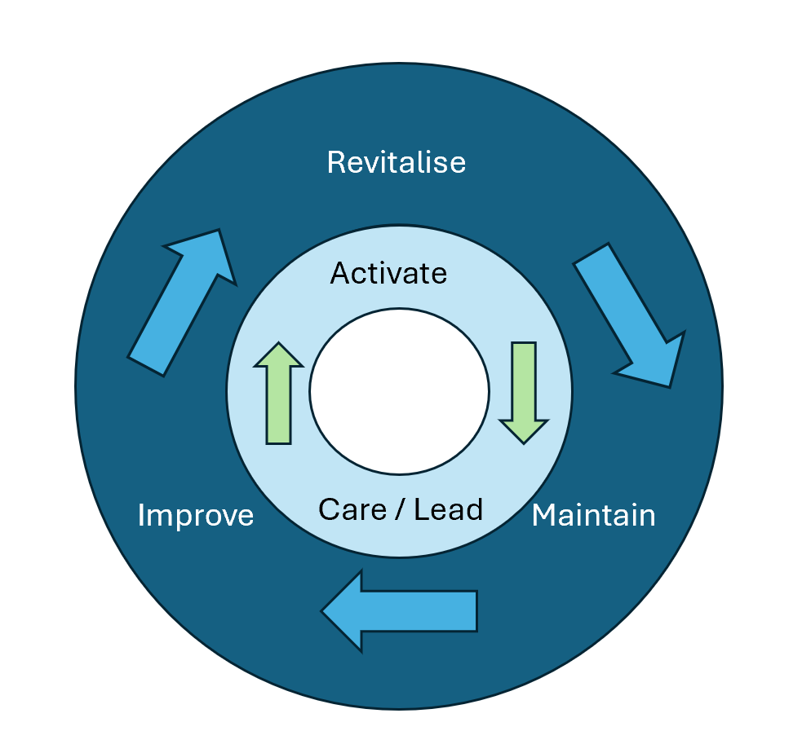  Business Precincts Framework:  Management Plan (inner ring)  Action Plan (outer Ring)
Together, these two plans form a cohesive and future-focused model that ensures Unley’s business precincts are stewarded consistently, supported sustainably, and activated strategically.
The alignment of the two documents is demonstrated below:
Strategic Framework | Duration | Extent | Scope | Responsibility
Business Precinct Action Plan | 10 years – Annual Plan  (Five Year Review) | 10 Precincts  (Established and Emerging) | Single Plan – co-ordinated directions for all precincts | Council – Annual Business Plan and Budget
Business Precinct Management Plan | 3 year (trial) – Annual Plan | 4 Precincts  (Established only) | Co-ordinated Plan across each Precinct | BEDAC, Leadership Group and Co-ordinator – Separate Rate

The Business Precinct Management Plan is represented below, and detailed in the following sections:
Management Plan
Precinct Administration |  |  | Single plan across all precincts, establishing the shared governance, annual planning cycle, and financial reporting needed to ensure that decisions are evidence-based and transparent.
 | Precinct  Impact |  | Deliver locally tailored initiatives through a coordinated approach to activation (events, marketing, branding, banner/lighting programs and related initiatives)

2.1 Business Precinct Administration
Business Precinct Administration is aimed at fostering strong, collaborative relationships across all business precincts and to remove the current burden on precinct volunteers.
The Administration service establishes the governance, annual planning, precinct engagement and reporting that is needed to ensure that decisions are evidence-based, accountable and informed by local business insights. The formalised approach through the establishment of the Business Precinct Co-ordinator will ensure transparency and accountability through reporting to BEDAC and the Council.
The services could include:
- Business Precinct Leadership Group Meetings - Formal meetings held quarterly bring together representatives from various business precincts. These meetings provide a platform for information sharing and reporting, as well as collaboration and alignment best practices and strategies that promote collective growth and resilience across all the precincts.
- Annual Business Precinct Walkthroughs - Day and night walkthroughs held to observe operations, identify issues, and discuss solutions directly with businesses and property owners.
- Development of Three Year Business Precinct Action Plans – Ongoing creation and refinement of plans to protect and enhance access, amenity, and activation, aligning with Community Vision 2050.
- Advocacy – Continued advocacy with Council for investment and interventions that improve business precinct performance.
- Professional Support - Training and learning opportunities tailored to the requirements of leadership needs of the Committee.
- Economic data – Regular analysis of economic indicators to inform targeted responses, evaluation of initiatives and planning of precinct-specific interventions.

The Business Precinct Administration service provides a commitment to maintaining dynamic and thriving business environments. By fostering leadership, strategic dialogue, and community support, this service enhances the collective capability of business precincts to adapt, innovate, and grow sustainably.
2.2 Business Precinct Impact
Business Precinct Impact enables coordinated programs of locally-based economic activities to strengthen precinct identity, attract visitation and support precinct performance. Tailored to each precinct, the planned 12 month program could include destination brand management, banner and decorative lighting projects, events, investment attraction and growth precinct enablement.
The Impact approach aims to drive greater value form separate rate funding to increase foot traffic, elevate customer experience, and create lively, engaging precincts that attract residents, workers, and visitors. Activation initiatives enhance precinct visibility, strengthen community identity, and support a thriving local economy.
Components of the Impact Plans for each precinct could include:
- Special Events, Campaigns and Programming - Seasonal markets, cultural festivals, local events, music activations, performances, art installations, fitness sessions, car-meets, and family-friendly events that attract visitors and encourage repeat engagement.
- Destination Marketing and Branding - Joint campaigns, precinct branding, and seasonal promotions that highlight the unique local culture, history, and identity and offerings of each precinct.
- Networking and Upskilling - Opportunities for businesses to connect, collaborate, and strengthen business skills, new business opportunities and business improvements.
- Investment Initiatives - Clear investment and business attraction propositions tailored to each precinct, including working with property owners to create short-term or pop-up opportunities for start-ups and new businesses to test market affordability.
- Seasonal Window Displays / Thematic Décor / Decorative Lighting - Coordinated decorations and themed installations that enhance street appeal (including night time economy) and align with seasonal or promotional campaigns.
- Community Partnerships - Collaborations with artists, schools, charities, and social enterprises to deliver creative and community-focused initiatives.
- Local Interventions - Targeted actions informed by annual economic data and considered by the Leadership Team as needed.
Many of the services are intended to be led by the Business Precinct Co-ordinator, with the input of local volunteers to assist with precinct deliver.
- Business Precinct Leadership Group (BPLG)
It is proposed to formalise the success of the previously established Reference Group to oversee the separate rate and its impact across the four precincts.
To ensure local representation and that decisions reflect the unique identities, needs and economic conditions of the four established business precincts, the composition of the BPLG will include up to two representatives from each precinct. Membership is voluntary.
Any reports will be provided to BEDAC for review and recommendation to Council. The Business Precinct Co-ordinator will be responsible for preparation of any agendas, reporting and minutes of the meetings.
The BPLG Framework and nomination process will be run by the Administration to seek representation from each of the precincts, working initially with the existing Associations to identify appropriate individuals.
The BPLG has the potential to expand over time to incorporate other emerging precincts, if the application of the separate rate is expanded.
- Oversight and Decision-Making
Any reports from the BPLG will go to Council’s established Business and Economic Development Advisory Committee (BEDAC). BEDAC will oversee the implementation of the Business Precinct Management Plan, guiding strategic priorities, reviewing annual precinct business plans, performance of the Co-ordinator, and providing advice to Council regarding precinct performance and utilisation of the separate rate.
- Resources
Implementation of the Business Precinct Management Plan will require the establishment of the Business Precinct Co-ordinator role, funded from the Separate Rate.
They will be the day-to-day point of contact for each precinct and responsible for the day-to-day management of the framework and delivery of annual plans. Their responsibility will be to service the four precincts and will not be associated with any other responsibilities of the Council. The role will be precinct focused and accountable to the precincts.
They will report to the Manager, Economic Development and Strategic Projects, who will maintain oversight and accountability for delivery, coordination with other Council departments and reporting to BEDAC and Council.
This structure ensures clear lines of accountability and adequate resourcing to support the ongoing management of precincts.
The Business Precinct Co-ordinator role will not duplicate the responsibilities of existing roles within Council’s Economic Development team and their city-wide growth focus.
- Separate Rate
The Business Precinct Management Plan provides a transparent structure for the appropriate expenditure of the Separate Rate, ensuring that all activities, services, and initiatives benefit the business precincts they are raised from.
The Business Precinct Management Plan aims to deliver a consistent, accountable, and resourced program that maximises impact to meet the evolving needs of each precinct.
In accordance with Section 154 of the Local Government Act, the wording of the declaration of the Separate Rate will include:
“to fund the planning, carrying out, making available, supporting, maintaining or improving the following activities that are, or are intended to be, of particular benefit to the land, or the occupiers of the land, within that part of the area, or to visitors to that part of the area:
- precinct enhancement initiatives, including but not limited to minor infrastructure works, streetscape upgrades, beautification projects and public realm maintenance and improvements;
- marketing and promotional initiatives to increase awareness, visitation and commercial activity within the precinct;
- events and activation programs designed to attract visitors and support local trade;
- business, planning, engagement and collaboration initiatives within the precinct, including but not limited to networking events, trader meetings, communication programs and stakeholder coordination activities,
and to meet the personnel and other costs associated with administering the above activities, for the financial year ending 30 June 2027.”
The Separate Rate will be pooled and allocated in accordance with the Business Precinct Management Plan, ensuring funds are directed to services and initiatives that deliver a particular benefit to the businesses, properties, and visitors of each precinct. Budgets will target 40% of total income towards ongoing Administration costs and 60% towards Impact initiatives, to be distributed proportionately based on each precinct’s contribution to the Separate Rate.
The Administrative costs will include the Business Precincts Coordinator role as well as administrative tasks that ensure transparency, accountability, and compliance with the legislative requirements governing the separate rate.
Historically, each Precinct was spending up to 60% of its annual income on administrative tasks.
- Precinct Engagement
Engagement will be tailored to the needs and scale of each precinct, ensuring businesses, property owners and key partners remain informed, involved and supported throughout planning and delivery. The following engagement pathways are proposed:
- Business Precinct Leadership Group – These formal meetings with nominated local precinct leaders will provide a regular platform for engagement across the four precincts and Council. These meetings provide opportunity for reporting to leaders the planned expenditure of the Separate Rate and ensure local knowledge and business insights inform decision-making.
- Associations / Reference Groups - Local Reference Groups will be established to offer a more informal and flexible way for traders and property owners to participate in planning discussions, contribute local perspectives, and collaborate with Council on delivering opportunities across the precinct. The Reference Group could be the continuation of the existing Trader Association.
- Annual Town Hall Meetings - To maintain open communication across all business precincts, Council will consider hosting an Annual Town Hall Meeting, for all that contribute to the Separate rate each year. These meetings will provide updates on the Business Precinct Management Plan, share annual work plans, outline upcoming initiatives, and give businesses an opportunity to raise ideas, ask questions and provide feedback.
- Planning, Monitoring and Reporting
Formal reporting will be undertaken by the Co-ordinator on behalf of each precinct. The documentation will ensure businesses, property owners and key partners remain informed where appropriate, throughout the year. These reports will be provided through BEDAC to Council, ensuring transparency and accountability. The following formal documentation is proposed for each Precinct:
- Business Precinct Action Plan - Tailored activation plans for business precincts that strengthen local economies, enhance precinct identity, and guide coordinated events, branding and economic development initiatives over a three year trial period.
- Annual Business Plan and Budget - An annual plan detailing proposed operational and project expenditure across all precinct services—including enhancements, activation, and campaigns is prepared and presented to BEDAC / Council for review and approval and made public to ensure financial transparency and accountability.
- Annual Report - To support accountability and continuous improvement, an annual reporting process will be established. This will include assessment of outcomes against annual Business Plan and Budget, enhancements, activations and campaigns, including reporting on key performance measures and financial targets.
- Review Cycle
A formal three-year review will ensure the Business Precinct Management Plan remains contemporary, responsive and aligned with organisational and business precinct expectations. This review process will be overseen by BEDAC and may recommend refinements to service levels, funding models or opportunities to expand to include other emerging business precincts.

